WEEK 3: ADVANCED DATA ANALYSIS AND VISUALIZATION IN LOGISTICS
Virtual Logistics Data Analyst Internship
Exploratory Data Analysis and Visualization Report

1. Introduction
This Week 3 task focuses on advanced data analysis and visualization in logistics. The purpose is to explore a hypothetical logistics dataset, identify patterns and relationships, and communicate findings through clear visualizations. Exploratory Data Analysis (EDA) is important because it helps analysts understand distributions, operational trends, cost drivers, and possible bottlenecks before more advanced predictive modeling is performed.

2. Data Simulation and Dataset Structure
A hypothetical dataset containing 500 shipment records was simulated using Python. The dataset represents logistics operations across four regions and three transport modes. The variables were designed to support analysis of delivery efficiency, shipment characteristics, transportation costs, and delayed deliveries.
- shipment_id – Unique identifier for each shipment.
- region – Operational region: North, South, East, or West.
- transport_mode – Road, Rail, or Air.
- shipment_volume – Volume associated with the shipment.
- distance_km – Distance travelled in kilometres.
- delivery_time_days – Actual delivery duration.
- transport_cost – Transportation cost associated with the shipment.
- delivery_status – Indicates whether the shipment was delivered on time or delayed.

3. Exploratory Data Analysis Methodology
The EDA process included descriptive statistics, measures of central tendency, distribution analysis, group-based comparisons, and correlation analysis. Python libraries Pandas and NumPy were used for data manipulation, while Matplotlib was used to create visualizations.
The simulated dataset produced an average delivery time of 5.04 days and a median delivery time of 4.95 days. The average transportation cost was 2191.60, while the overall simulated delay rate was 15.80%.

4. Descriptive Statistics
Metric | Shipment Volume | Distance (KM) | Delivery Time (Days) | Transport Cost
Mean | 102.36 | 640.61 | 5.04 | 2191.6
Median | 91.85 | 644.04 | 4.95 | 2167.62
Std | 53.26 | 277.46 | 2.15 | 680.43
Min | 10.0 | 50.0 | 1.0 | 569.74
Max | 291.74 | 1414.64 | 11.02 | 4355.17
These statistics provide a first understanding of the typical shipment, the spread of operational values, and the presence of potentially extreme observations.

5. Visualization 1: Delivery Time Distribution
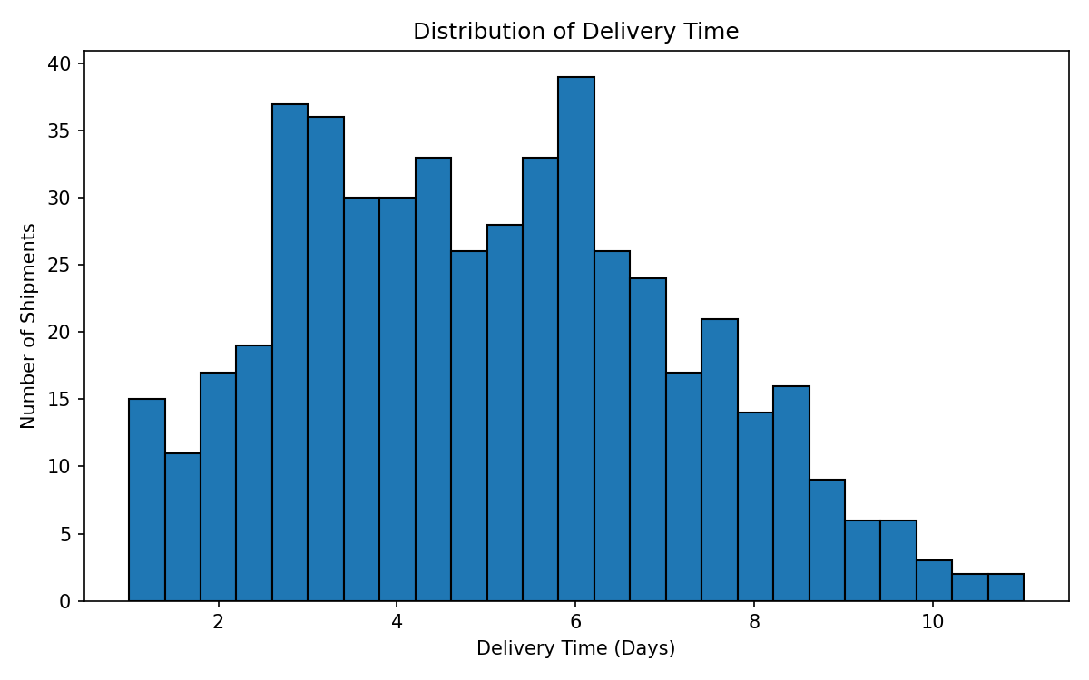
A histogram was selected because it clearly shows the distribution and frequency of delivery times. This visualization helps identify the most common delivery range and whether the data contains unusually long delivery durations that could indicate operational bottlenecks.

6. Visualization 2: Transportation Cost by Transport Mode
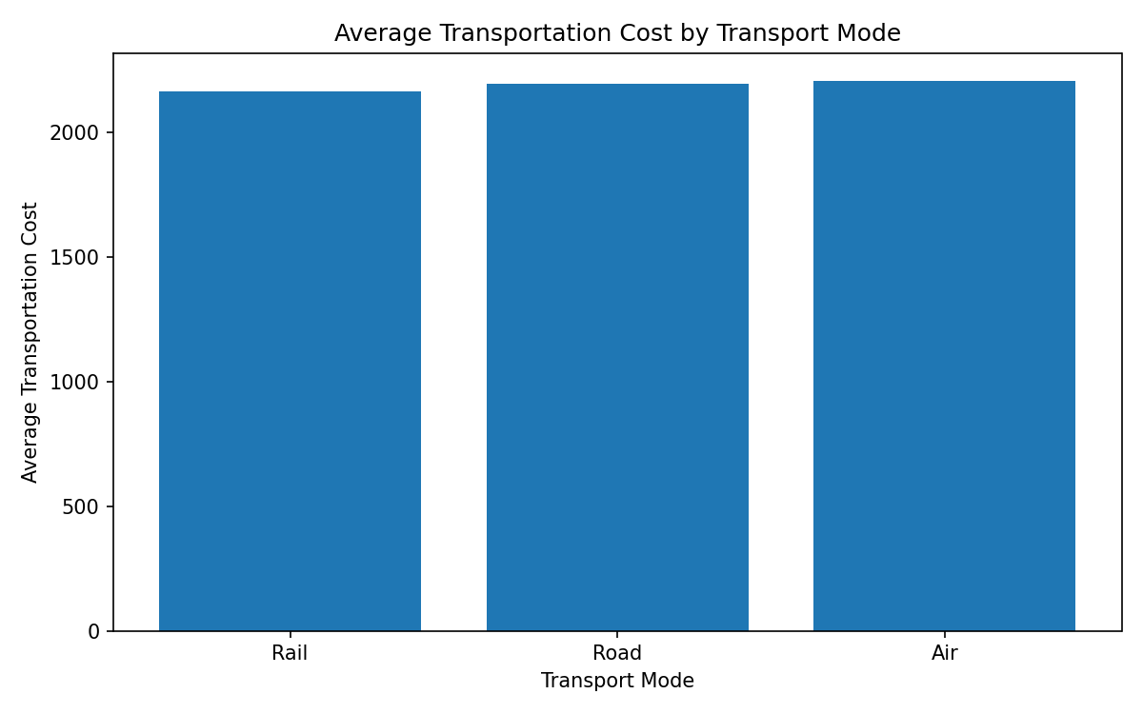
A bar chart was used to compare average transportation costs between transport modes. In the simulated data, Air has the highest average transportation cost. This comparison supports resource allocation and helps identify where cost-management strategies may be required.

7. Visualization 3: Distance and Transportation Cost
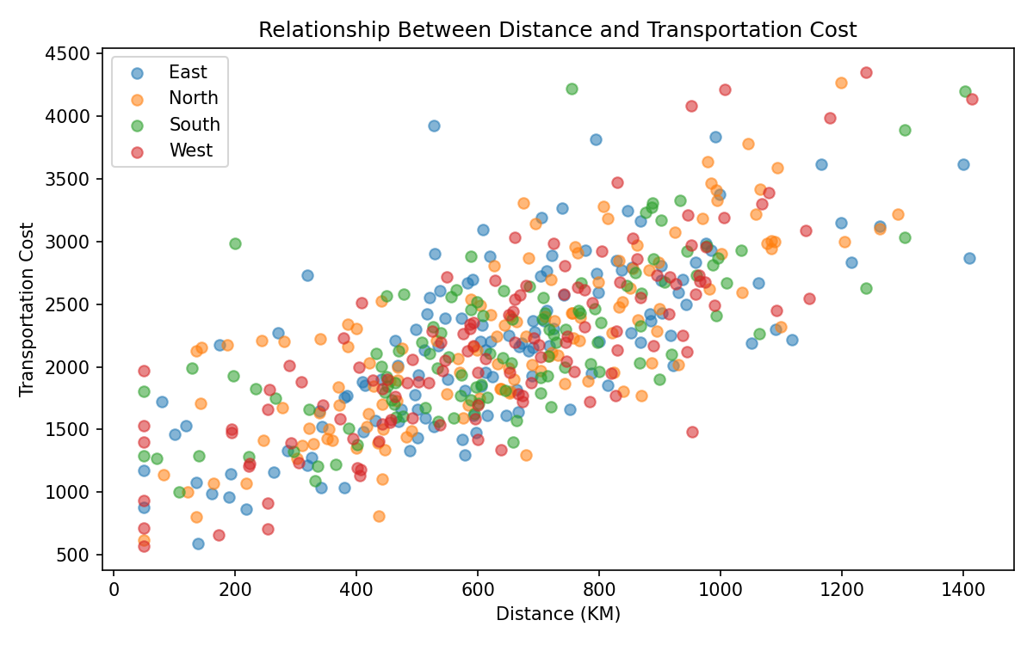
A scatter plot was selected to examine the relationship between two continuous variables: distance and transportation cost. The visual pattern demonstrates how transportation cost generally changes as shipment distance increases. Regional labels also allow operational differences to be explored.

8. Visualization 4: Average Delivery Time by Region
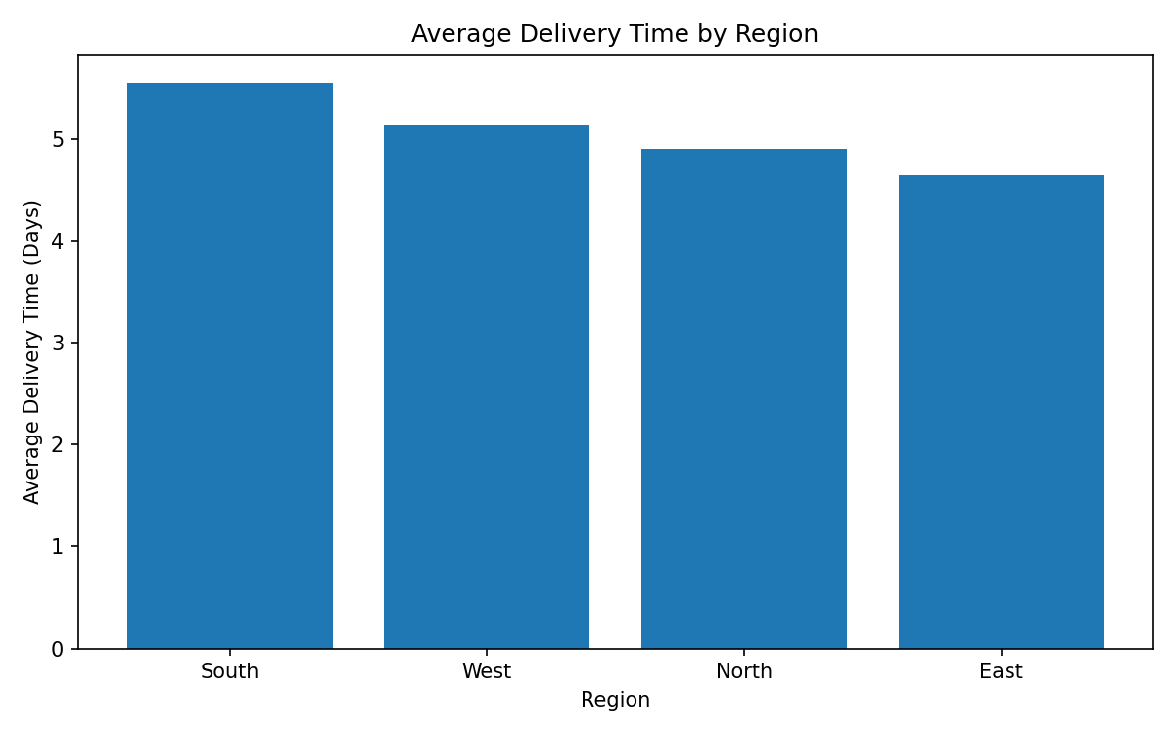
A bar chart compares regional delivery efficiency. In the simulated dataset, South has the highest average delivery time. A region with consistently longer delivery durations could require further investigation into route conditions, warehouse location, demand patterns, or transportation capacity.

9. Visualization 5: Delivery Status
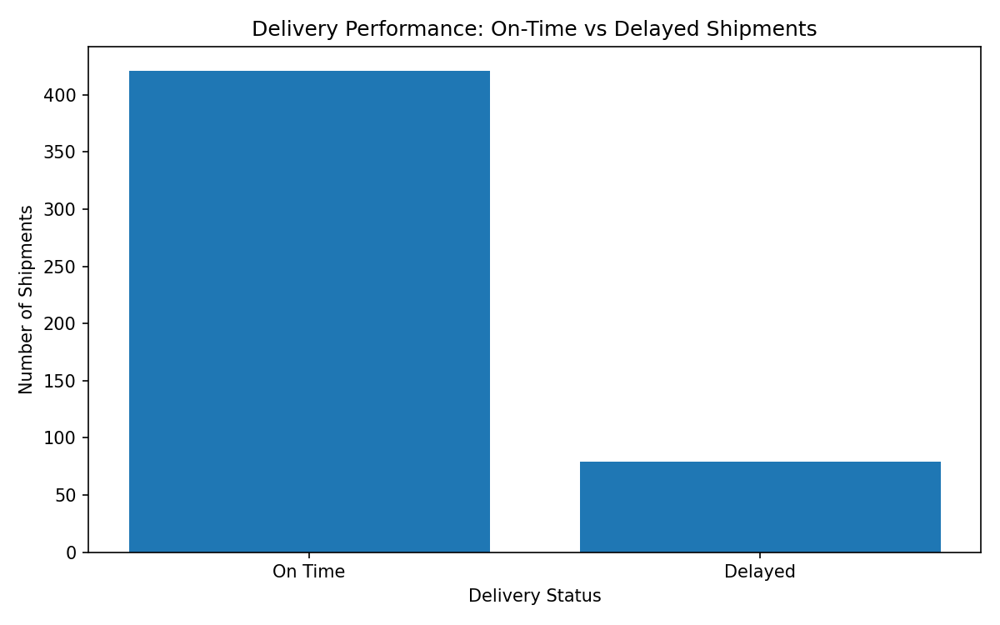
This chart compares on-time and delayed shipments. It provides a direct operational performance view and can be used as an initial indicator of service reliability. A high delayed-shipment count would justify further analysis of the variables associated with late deliveries.

10. Correlation Analysis
Variable | shipment_volume | distance_km | delivery_time_days | transport_cost
shipment_volume | 1.0 | -0.04 | -0.02 | 0.56
distance_km | -0.04 | 1.0 | 0.68 | 0.74
delivery_time_days | -0.02 | 0.68 | 1.0 | 0.51
transport_cost | 0.56 | 0.74 | 0.51 | 1.0
Correlation analysis helps identify linear relationships between logistics variables. The results should be interpreted together with the visualizations because correlation does not establish causation. Variables showing stronger relationships can be considered as potential inputs for future predictive models.

11. Analytical Insights
- Delivery time analysis helps identify the distribution of normal operations and potential bottlenecks caused by unusually long deliveries.
- Transportation cost varies according to operational characteristics such as distance, shipment volume, and transport mode.
- Distance is an important potential cost driver and should be considered when evaluating route efficiency and transportation budgets.
- Regional comparisons can identify locations that may require additional operational investigation or resource allocation.
- The delayed-versus-on-time comparison provides a high-level indicator of service performance and can support future delay prediction models.

12. Recommendations
- Investigate regions with higher average delivery times to identify route, capacity, or infrastructure bottlenecks.
- Monitor transportation cost against distance and shipment volume to improve cost forecasting.
- Develop additional KPIs such as on-time delivery rate and cost per kilometre for regular performance monitoring.
- Use the cleaned and explored variables as features in future machine-learning models for delivery delay prediction.
- Create an interactive dashboard in a future phase to allow logistics managers to monitor KPIs and trends.

13. Python Code Excerpts
import pandas as pd
import matplotlib.pyplot as plt
df = pd.read_csv("week3_hypothetical_logistics_data.csv")
print(df.describe())
print(df.corr(numeric_only=True))
plt.figure(figsize=(8, 5))
plt.hist(df["delivery_time_days"], bins=25, edgecolor="black")
plt.title("Distribution of Delivery Time")
plt.xlabel("Delivery Time (Days)")
plt.ylabel("Number of Shipments")
plt.show()
mode_means = df.groupby("transport_mode")["transport_cost"].mean()
plt.figure(figsize=(8, 5))
plt.bar(mode_means.index, mode_means.values)
plt.title("Average Transportation Cost by Transport Mode")
plt.show()
plt.figure(figsize=(8, 5))
plt.scatter(df["distance_km"], df["transport_cost"], alpha=0.55)
plt.title("Distance vs Transportation Cost")
plt.xlabel("Distance (KM)")
plt.ylabel("Transportation Cost")
plt.show()

14. Conclusion
This Week 3 analysis demonstrates how Exploratory Data Analysis and visualization can support logistics decision-making. The hypothetical dataset was analyzed using descriptive statistics, distributions, group comparisons, and correlation analysis. The visualizations make operational patterns easier to interpret and help identify possible cost drivers, regional performance differences, delivery bottlenecks, and service-level issues. The results provide a foundation for future KPI monitoring, predictive modeling, and optimization in subsequent stages of the logistics analytics project.

